Problem Statement 2:

Ingest data from multiple tables in SQL Server database to Azure Blob storage.

* I already have my data factory, no need to create another one.
* I created a linked service, **AzureSqlDatabaseLinkedService** to link my database in Azure SQL Database to the data factory.
* I created a dataset for source SQL Database which specifies the name of the database and the table that contains the source data.
* I created a dataset for sink Azure Synapse Analytics
* The input dataset AzureSqlDatabaseDataset refers to the AzureSqlDatabaseLinkedService. The linked service specifies the connection string to connect to the database. The dataset specifies the name of the database and the table that contains the source data.
* The GetTableListAndTriggerCopyData pipeline performs two actions:
* Looks up the Azure SQL Database system table to get the list of tables to be copied.
* Triggers the pipeline IterateAndCopySQLTables to do the actual data copy.
* The IterateAndCopySQLTables pipeline takes a list of tables as a parameter. For each table in the list, it copies data from the table in Azure SQL Database to Azure Synapse Analytics using staged copy and PolyBase.
* The output dataset AzureSqlDWDataset refers to the AzureSqlDWLinkedService. The linked service specifies the connection string to connect to the Azure Synapse Analytics. The dataset specifies the database and the table to which the data is copied.
* I created two pipelines: IterateAndCopySQLTables and GetTableListAndTriggerCopyData Looks up the Azure SQL Database system table to get the list of tables to be copied.
* Triggers the pipeline "IterateAndCopySQLTables" to do the actual data copy.
* While monitoring the pipelines, I kept refreshing till I saw that all the pipelines succeeded.

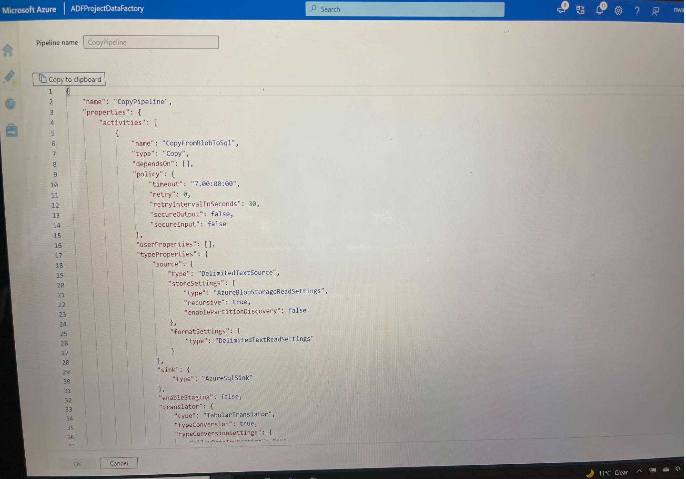

Figure 1. JSON statement output result of pipeline run

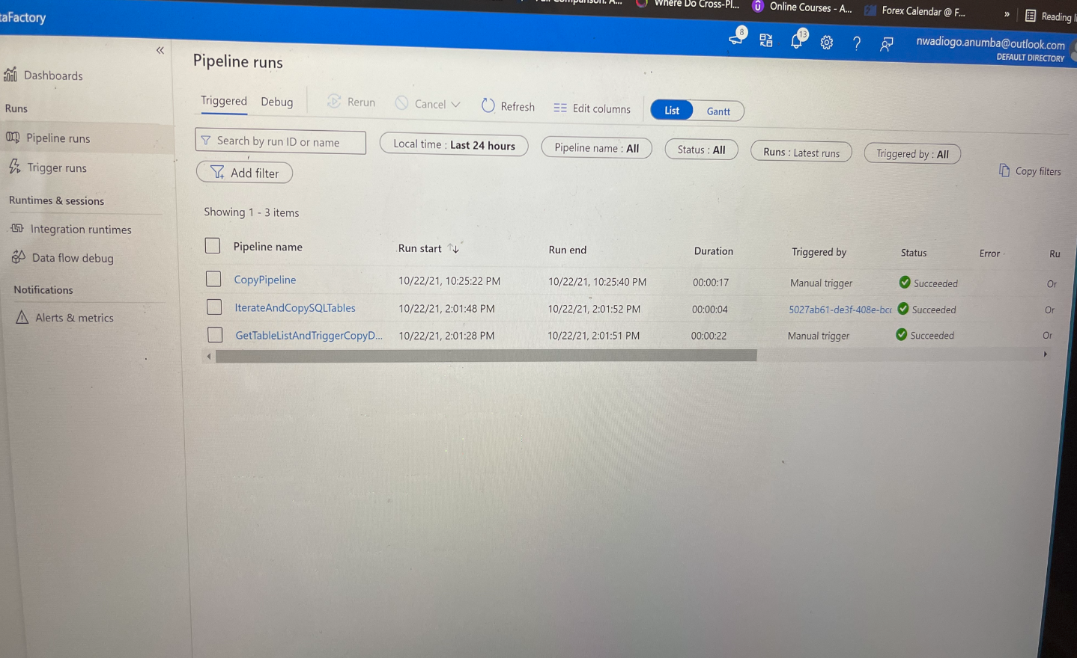

Figure 2. Succeeded Pipeline run to copy data from Blob to SQL